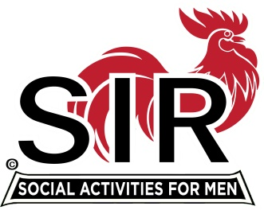
Draft Proposed 2022 Branch 116 Goals
Remember we’re a volunteer organization with the objective and making lifelong friends and having fun

- Conduct a 1st quarter assessment of key branch issues coming out of covid situation

  - Include consideration of Covid issues and return to normal branch operations
  - Status and health of existing branch activities
  - Interest in New Activities (Cooking, Travel Venue, CPR, Theater/Opera, smaller and or more dinner groups, wine/beer making, Table Top Tennis, Photography, bowling, community service, stock investment, Cycling, etc.)
  - Shared Activities with other Branches
  - Finalizing Branch growth targets and membership options
  - Use of Annual Survey and an Assessment Working Group to conduct an overall branch assessment
  - Additional Leadership and Support Positions that may be needed
  - Complete by 3/31/2022

- Attract and Retain Membership with a target of a 15% increase in membership above the post covid member count (i.e. roughly first Qtr after membership stabilizes).

  - Increased spousal Involvement and participation across Branch activities and recruiting efforts to attract and recruit member family friends (provide trifold + incentive)
  - Make sure 2022 Branch activities and events are in alignment with membership interests (based on online survey and table top survey)
  - Periodically publish member stories and personal histories within the Branch (Maybe Sir of the quarter). Possible posting of member Bio’s linked to photos on web site.
  - Reach out to men of all ethnic backgrounds that may be interested in SIR membership
  - Expand number of activities and share with other Branches where it makes sense to do so
  - Leverage SIR Branding Updates and materials
  - Conduct monthly Branch Growth Team meetings with the RAMP Leaders, Membership Secretary, Web, Newsletter, and key Branch Support leaders
  - Annually decide on how many new activities to target for development
  - Provide a quarterly incentive for members bringing in new members to the branch

- Get more members involved with Branch Operations and Branch Activities with Member Relations follow-up and contact plan including personal calls to members

- Establish a community service pilot activity for interested members

- Plan and hold a Big Branch Social for kick starting post covid era in form of the Spring Fling or earlier event

- Communicate Across the Board with more member direct contact (phone and e-mail) while balancing the frequency of contact (i.e. weekly e-mail Branch update, single issue phone poll, etc.)

- Update Luncheon Meeting format in support of more social interaction between members

  - Table introduction protocol
  - Table Captain Team for issue based discussions, introductions , and feedback
  - Table incentives for increasing open seating
  - Early availability of entry tables (payment, raffles, nametags, etc.) to support earlier social hour for lunch meeting
  - Consider quarterly open table seating and have branch officers and directors seated at separate tables when possible
  - Meeting Agenda efficiency improvements and innovative format changes

